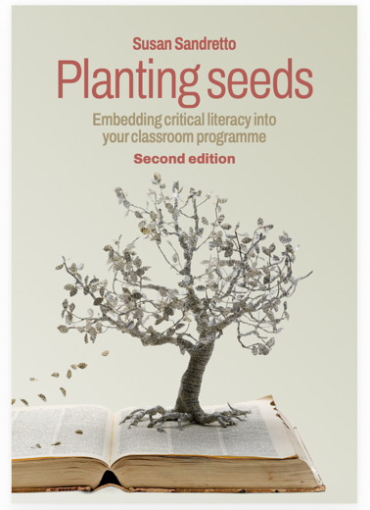

Practising Critical Literacy: An “Unworkbook” for Planting Seeds
I have gathered the chapter focus questions, reflective interludes and chapter concluding reflections into an ‘Unworkbook’. I am loath to call it a workbook because there are no right answers. The questions are prompts for reflection. You can reflect on your own by writing down your responses, or in a critical literacy community of practice. I have also included the Critical Literacy Self-Assessment Tool (Chapter 1, Figure 1), Self-audit Tool (Chapter 3, Figure 7), Observation Tool (Chapter 3, Figure 8), Critical Literacy Lesson Design Template (Chapter 4, Figure 10) and the Text Selection Audit Tool (Chapter 4, Figure 11).

Chapter 1 Introduction: Why is critical literacy important?
Chapter focus questions | Reflections
What are your current understandings of critical literacy? (Did you complete the critical literacy self-assessment tool?)
How often do you practice critical literacy in your personal and/or professional life?
What do you hope to learn?
Reflective interludes | Reflections
How does the lesson extract affirm or complicate your current understandings of critical literacy?
What is missing from my “stretched” version of literacy?
What metalanguage have you met before? What is new? Which terms do you want to learn more about?
What enables your agency as a teacher?
What constrains your agency as a teacher?
What has been your experience of communities of practice for professional learning and development in the past? Can you leverage those experiences to support a CoP for critical literacy in your current context?
Chapter 1 Concluding reflections | Reflections
Where will you begin your journey?
Which path will you follow?
Who will you bring with you?
Chapter 2 Theorising practice: What is critical literacy?
Chapter focus questions | Reflections
What does power have to do with critical literacy practices?
What are some different theories used for critical literacy?
What is the role of critique and critical thinking in critical literacy?
How is critical literacy defined for Planting Seeds?
Reflective interludes | Reflections
Which theories do you use to inform your professional practice?
What is your understanding of critical theory now?
How is power conceptualised through critical theory?
How might you use critical theory to inform your classroom practice?
What is your understanding of postmodern and poststructural theories now?
How is power conceptualised through postmodern theories?
How might you use poststructural theory to inform your classroom practice?
Which theories are you drawn to? Why?
What is your understanding of critical thinking?
What is your thinking about the relationships between critical thinking and critical literacy?
What do you think is the place of affect for critical literacy practices?
Why might we need critical hope to reinforce critical literacy practices?
What is missing from the critical literacy conceptual building blocks?
Which areas do you want to explore further?
Chapter 2 Concluding reflections | Reflections
What is your current understanding of theory?
What is your thinking about the relationship between theory and practice?
Which theories currently inform your literacy instruction?
What is your current understanding of the concepts critical theory, poststructuralism and critical postmodernism?
Which theories do you think will underpin your critical literacy pedagogy? Why?
Chapter 3 Dialogic pedagogy: How do you teach critical literacy?
Chapter focus questions | Reflections
What is the role of dialogic pedagogy for critical literacy lessons?
How can you support students to do the ‘heavy lifting’ of the discussion?
What tools can you teach to support dialogic interactions?
Reflective interludes | Reflections
How do you currently use dialogue?
What would you like to change (if anything)? Why?
What is your current understanding of culturally responsive and sustaining pedagogies?
What might they look like in your classroom?
What is your understanding of authentic questions for critical literacy learning?
How can open questions support students to develop critical literacy practices?
How can teachers avoid closing down students’ contributions when using authentic questions?
What are some limitations of the IRE/F pattern?
Which goals might lead you to use an IRE/F structure?
As a member of your class, which talk rule will you add to the list?
Which Talk Tools do you use already?
Which Talk Tools do you see yourself implementing?
Which area of your dialogic pedagogy will you select to reflect on first? Why?
How could you establish a teacher study group? Or who could you approach to be a critical friend?
Chapter 3 Concluding reflections | Reflections
What do you view as the role of dialogic pedagogy for critical literacy lessons?
What are some new tools that you can use to support students to do the ‘heavy lifting’ of the dialogue?
Chapter 4 Practising theory: How do you design critical literacy lessons?
Chapter focus questions | Reflections
What are some design considerations for critical literacy lessons?
Which texts can you select for critical literacy lessons?
Which questions can you ask?
What texts can be constructed in response to critical analysis?
Reflective interludes | Reflections
What questions do you have about lesson planning as design work?
Which colleagues could you work with to design critical literacy lessons?
Which texts will you select first? Why?
Which modes of meaning will you focus on (e.g., written or oral language, audio, gestural, spatial, tactile or visual mode)? Why?
Which familiar texts might you revisit with a critical literacy focus?
How will you audit your programme to support students to critically analyse a range of texts and modes of meaning?
Which questions will you pose? Why?
Which critical literacy conceptual building blocks will you emphasise? Why?
How will you ensure you ask a range of questions?
Which metalanguage terms will be important for your students?
What strategies can you use to teach the metalanguage?
How many types of texts do your students currently transform or create?
How will you support students to transform and create a range of text types using a variety of modes of meaning?
How can you leverage current units of study or topics to integrate opportunities for students to transform and create texts while practising critical literacy?
What additional learning do you need to complete about AI, the environment or misinformation before you support your students to practice critical literacy on these topics?
Where could you begin to integrate critical analysis of texts generated by AI, texts representing the environment or texts (possibly) containing misinformation into your programme?
Chapter 4 Concluding reflections | Reflections
Which text will you use first?
Which colleagues can you work with to collaboratively design lessons and share examples of your practice with?
Viewing critical literacy as a long-term practice, as opposed to a discrete skill, how can you weave it in as a regular component of your programme?
Chapter 5 Assessment: How do you capture student learning in critical literacy?
Chapter focus questions | Reflections
What types of assessment do you regularly use in the literacy programme?
How could they be adapted to plan next steps for students’ critical literacy learning?
How can you track students’ critical literacy practices?
Reflective interludes | Reflections
What images does the term assessment bring to mind?
Which generation(s)of assessment practices do you currently use? In which areas? Why?
When you think about recent assessment decisions you have made, what was the primary purpose: to inform next teaching steps, to make a judgement, or to support students to assess their own learning? How did that purpose shape what you noticed and responded to?
Name some of the tools you currently use that could be positioned as assessment for learning.
Do you currently make use of peer and self-assessment practices? Why or why not?
What types of feedback do you give most frequently? In what ways would you like to change your feed-up/feedback/feed-forward practices (if any)? Why?
Chapter 5 Concluding reflections | Reflections
How will you work productively with the inherent tensions involved in assessing critical literacy practices?
Chapter 6 Student voice: How can listening to students inform critical literacy teaching and learning?
Chapter focus questions | Reflections
What is your understanding of the term “student voice”?
Have you gathered student voice in the past to critically reflect on your teaching? How? If so, how did you let the students know if you listened?
What are some affordances and challenges of using student voice to inform critical literacy teaching?
Reflective interludes | Reflections
How do I currently create opportunities to listen to all students’ perspectives?
In what ways can student voice be used in my classroom to support students’ rights to be heard and taken seriously?
How might power relations shape which students feel able to speak, what they say or how student voice is taken up or acted on?
What are some roses and thorns you have experienced when listening to students?
How can you communicate to students that you have heard their voices?
How can you critically reflect on what students tell you to refine your critical literacy pedagogy?
What will be some key considerations for gathering and listening to student voice in your context?
Which methods do you think will work in your context to gather student voice?
Chapter 6 Concluding reflections | Reflections
What have been the most prominent take-home messages for you about using student voice to reflect on your critical literacy pedagogy?
Will you use student voice to prompt reflection on your critical literacy pedagogy? Why or why not?
Chapter 7 Ethics and affect: How can teachers navigate ethical and affective tensions in their critical literacy programme?
Chapter focus questions | Reflections
What might be some of the ethical and affective challenges of teaching critical literacy?
What resources can you draw on for support as you reflect on and negotiate these challenges?
Reflective interludes | Reflections
What “ethically important moments” (Guillemin & Gillam, 2004) have you met in your teaching lately? How did you work through them?
What is your current normative stance in the classroom?
How might this stance affect critical literacy pedagogy?
Does your current understanding of critical literacy include social action?
What forms of social action would you support students to take in the classroom? Why?
What is your understanding of the ethics of care of the self?
How might you use ethics of care of the self to reflect on your critical literacy pedagogy?
Which texts will you construct to prompt your critical reflections?
Think of an “ethically important moment” (Guillemin & Gillam, 2004) you had recently and apply some of the reflective questions. What ethical issues were raised?
Reflecting on that moment now, would you do anything differently?
What is your normative ground?
Do you find the idea of free thinking within a parameter useful? Why or why not?
Chapter 7 Concluding reflections | Reflections
What is your normative ground for critical literacy lessons? Has it shifted after engaging with this chapter?
How might you work with affective responses (yours and your students) to sustain hopeful critical literacy practices?
Chapter 8 Conclusion: Where to next?
Chapter focus questions | Reflections
We have covered the theories of critical literacy (Chapter 2), dialogic pedagogy (Chapter 3), lesson design (Chapter 4), assessment practices (Chapter 5), student voice (Chapter 6) and the ethics of critical literacy (Chapter 7). Which chapter(s) do you feel confident with? Which chapter(s) do you want to revise?
Have you completed the Critical Literacy Unworkbook? What goals have you set for your next steps?

Critical Literacy Self-Assessment Tool (Chapter 1, Figure 1)
(Annotate with comments or examples)
Scale* | Emerging | Developing | Proficient | Extending
I can evidence the following understandings in my practice— | an initial understanding of the concept, but may need scaffolding | a partial understanding of the concept, but may need prompting | a complete understanding of the concept, including providing a justification | a sophisticated understanding of the concept
Understandings about texts
Texts are social constructions.
Texts are not neutral.
Texts are (typically) multimodal.
Texts can have gaps or silences.
Texts offer representations of people/topics.
Texts have power and consequences.
Texts provoke affective embodied engagement.
Understandings about text creators
Text creators mobilise language and power (discourses) using multiple modes.
Text creators (typically) design texts for a particular audience and purpose.
Text creators make choices influenced by their beliefs, knowledges, experiences, and social, cultural, and linguistic resources and worldviews.
Text creators include some people/topics.
Text creators exclude some people/topics.
Text creators depict particular representations of people/topics.
Text creators use different techniques to persuade.
Understandings about text analysts
Text analysts have diverse beliefs, knowledges, experiences, social, cultural and linguistic resources, and worldviews.
Text analysts will produce diverse understandings of texts.
Text analysts use their affective, embodied interactions with texts as meaning-making resources.
Text analysts make connections between texts and their lived experiences.
Text analysts critically consider multiple perspectives.
Texts analysts sustain their practices with critical hope.

*Scale adapted from (British Columbia Government, 2023).

Self-audit Tool (Chapter 3, Figure 7)

- Begin by audio/video-recording a typical literacy lesson (could be small group or whole class).
- Then convert the audio into a transcript for analysis. There are many tools to make this easier. Try using Microsoft 365, Zoom, or Google Docs.
- Respond to the reflective questions below.

Reflective questions
Who initiates discussion (teacher or student)?
How do you respond to student contributions?
Who does most of the talking during the lesson? (Take a close look at turn taking).
What else did you observe?
What are your next steps as a result of this analysis?

Observation Tool (Chapter 3, Figure 8)

Date: | Teacher: |  |  | Observer: |  | Topic:
Highlight relevant Talk Goals and Talk Tools
Goal: Support students to … |  | Talk Tool |  |  | Sample stem
1. clarify, expand and share their thinking |  | Think time |  |  | “Before you respond, I want us all to take a few moments to think about …”
 |  | Say more |  |  | “Can you tell me a bit more about …”
 |  | Revoice |  |  | “So, are you saying … Have I got that right?”
2. listen to each other |  | Repeat |  |  | “Who can put what [student] just said into their own words?”
3. deepen their reasoning |  | Ask for evidence |  |  | “Why do you think that?”  “Can you provide some evidence for that?”
 |  | Challenge |  |  | “Is that always the case? Who has a different example/point of view?”
 |  | Ask open authentic questions |  |  | Open authentic questions do not presuppose a correct answer and allow for multiple responses.
 |  | Revise and reflect |  |  | Questions that revise content and reflect on their learning.
4. think with each other |  | Agree/disagree |  |  | “Who agrees/disagrees with what [student] said? Why?”
 |  | Add on |  |  | “Can anyone add on to what [student] was saying about …”
 |  | Explain what someone else means |  |  | “Why do you think [student] said that?”
Timing/Phase/Talk Format/Talk Strategies  (Whole class, small group, partner talk) |  |  | Notes on focus during observation
Teacher actions |  |  | Student actions
Post observation discussion
Reflective dialogue between observer and observed (post-lesson) |  |  | Possible focus questions:  - Did the students meet the learning objectives (for dialogue) for this lesson? Why or why not?  - Who did most of the talking?  - What worked well?  - What do you want to change for the next lesson?
Next steps

Adapted from (Chapin et al., 2003; Michaels & O’Connor, 2012)

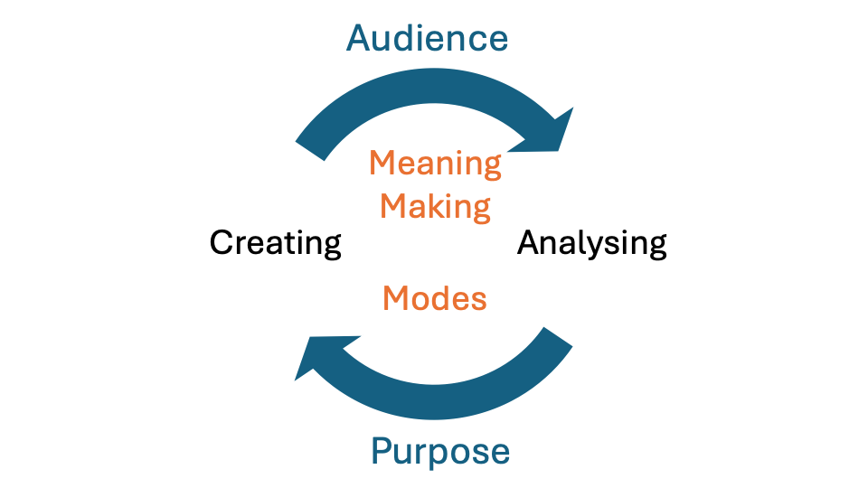
Critical Literacy Lesson Design Template (Chapter 4, Figure 10)

*This template can be used for designing single lessons or adapted as a coversheet for a unit. It can be used to focus on analysing and/or transforming or creating texts.
Date(s): | Learning area(s): Where do you want to locate the lesson? (e.g., English, science, maths …) |  |  | Timing/phase/talk format  (Whole class, small group, pairs, particular talk structures? You might use several.)
Text(s): | Modes of meaning focus:  While most texts are multimodal you will probably wish to focus on only 1 or 2 modes.  - Oral language  - Written language  - Audio mode  - Gestural mode  - Spatial mode  - Visual mode  - Tactile mode |  |  | Rationale for text selection:  You might speak to the purpose and/or audience, modes of meaning, curriculum area or other aspect influencing text selection. |  | Metalanguage:  Is there any vocabulary that needs unpacking and/or explicit teaching?
Talk Goal: Support students to  - clarify, expand and share their thinking  - listen to each other  - deepen their reasoning  - think with each other |  | Talk Tools:  o Think time o Say more o Revoice  o Repeat  o Ask for evidence o Challenge o Ask open authentic questions o Revise & reflect  o Agree/disagree o Add on o Explain what someone else means
Questioning
Which questions will you pose to support critical analysis (see Table 8).
Will you have the students select or generate questions?

Conceptual building blocks of critical literacy
Understandings about texts |  |  | Understandings about text creators |  | Understandings about text analysts
- Texts are social constructions.  - Texts are not neutral.  - Texts are (typically) multimodal.  - Texts can have gaps or silences.  - Texts offer representations of people/topics.  - Texts have power and consequences.  - Texts provoke affective embodied engagement. |  |  | - Text creators mobilise language and power (discourses) using multiple modes.  - Text creators (typically) design texts for a particular audience and purpose.  - Text creators make choices influenced by their beliefs, knowledges, experiences, social, cultural, and linguistic resources and worldviews.  - Text creators include some people/topics.  - Text creators exclude some people/topics.  - Text creators depict particular representations of people/topics.  - Text creators use different techniques to persuade. |  | - Text analysts have diverse beliefs, knowledges, experiences, social, cultural and linguistic resources and worldviews.  - Text analysts will produce diverse understandings of texts.  - Text analysts use their affective, embodied interactions with texts as meaning-making resources.  - Text analysts make connections between texts and their lived experiences.  - Text analysts critically consider multiple perspectives.  - Texts analysts sustain their practices with critical hope.
Lesson introduction
Could begin with revising the class Talk Rules (See Chapter 3).
Present and unpack any metalanguage
Share the lesson focus (Which Talk Tools? Which critical literacy conceptual building blocks?)

During the lesson
Which questions will support critical analysis of the text? (See Table 8)
Which Talk Tools (Table 5) and/or Talk Strategies (Table 6) will you use?
Will students create texts in response? Which modes will they use?

Lesson conclusion
You can “bookend” the lesson by returning to the Talk Goals/Tools critical literacy conceptual building blocks you named at the beginning.

Post-lesson teacher reflections
What worked well?
What needs more work?
Trying taking some of the critical literacy questions to the lesson (e.g. Whose views were included in the discussion/activities?)

Next steps

Text Selection Audit Tool (Chapter 4, Figure 11)

Modes of meaning | Paper | Live  (Face-to-face or through digital platform; e.g., Zoom) | Digital
Written language
Oral language
Audio mode
Gestural mode
Spatial mode
Tactile mode
Visual mode

